# Visvesvaraya Technological University Belagavi-590 018, Karnataka



A Mini Project Report on

# “PET-SHOP MANAGEMENT”

**Mini Project Report submitted in partial fulfillment of the requirement for the DBMS Laboratory with Mini Project [18CSL58]**

# Bachelor of Engineering

**in**

# Computer Science and Engineering

## Submitted by

**Sharanya Shastri**



# Department of Computer Science and Engineering Jyothy Institute of Technology Tataguni, Bengaluru-560082

**Jyothy Institute of Technology Tataguni, Bengaluru-560082**

# Department of Computer Science and Engineering



**CERTIFICATE**

Certified that the mini project work entitled **“PET-SHOP MANAGEMENT”** carried out by **Sharanya Shastri** bonafide students of Jyothy Institute of Technology, in partial fulfilment for the award of **Bachelor of Engineering** in **Computer Science and Engineering** department of the **Visvesvaraya Technological University, Belagavi** during the year **2022-2023**. It is certified that all corrections/suggestions indicated for Internal Assessment have been incorporated in the Report deposited in the departmental library. The project report has been approved as it satisfies the academic requirements in respect of Project work prescribed for the said Degree.

Mrs. Sunitha Dr. Prabhanjan S

Guide, Asst. Professor Professor & HOD

Dept. of CSE Dept. of CSE

External Viva Examiner Signature with Date : 1.

2.

# ACKNOWLEDGEMENT

Firstly, we are very grateful to this esteemed institution **“Jyothy Institute of Technology**” for providing us an opportunity to complete our project.

We express our sincere thanks to our **Principal Dr. Gopalakrishna K** for providing us with adequate facilities to undertake this project.

We would like to thank **Dr. Prabhanjan S, Professor and Head of Computer Science and Engineering** Department for providing for his valuable support.

We would like to thank our guides **Mrs. Sunitha, Assistant Professor**

for their keen interest and guidance in preparing this work.

Finally, we would thank all our friends who have helped us directly or indirectly in this project.

**Sharanya Shastri K.R.**

# ABSTRACT

The application is designed to make the existing system more reliable, fast and easy for all, provides a methodical way of managing large databases. For this application we used the backend as SQL to store the data which is used in the application and for the user interface we have used PHP.

The objectives of this project are to provide web based interface to a pet shop owner to manage his pet shop activities. To provide an option for storing and managing the basic information about pets and pet products in the shop.

To provide an option for storing and managing the sales details of the shop. To provide an option for storing and managing the basic information about the customers. To track the information about sold pets and products to a customer.

# TABLE OF CONTENTS

|  |  |
| --- | --- |
| **SL No** | **Description** |
| 1 | INTRODUCTION |
| 2 | DESIGN |
| 3 | IMPLEMENTATION |
| 4 | RESULTS AND  SNAPSHOTS |
| 5 | CONCLUSION |

## CHAPTER 1:

**INTRODUCTION**

* 1. **Introduction to DBMS**

A database is simply an organized collection of related data, typically stored on disk, and accessible by many concurrent users, it is a logically coherent collection of data with some inherent meaning, representing some aspect of real world and which is designed, built and populated with data for a specific purpose.

Databases are managed by a Database Management System (DBMS) which is a collection of programs that enables user to create and maintain a database.

**Advantages of DBMS:**

Redundancy is controlled.

Unauthorized access is restricted. Providing multiple user interfaces. Enforcing integrity constraints.

Providing backup and recovery.

## Introduction to SQL

Structured Query Language (SQL), is a language used to request data from a database which includes database creation, deletion, retrieval of required tables and even manipulation of data held in a relational database management system.

SQL is considered as a Non-Procedural or a High level language in which the expected result or operation is given without the specific details about how to accomplish the task. So, SQL is a declarative language.

Therefore, SQL is designed at a higher conceptual level of operation than procedural languages as procedural languages includes only the information about opening and closing tables, loading and searching indexes, or flushing buffers and writing data to file systems, but the lower level logical and physical operations are not specified in SQL.

**INTRODUCTION TO PET SHOP DATABASE**

Pet Shop Management is a product based application that works within a centralized network. This project presents a review on the software program “Pet Shop Management” as should be used for pet care and products related to it. It is used for keeping track of all the animals and birds which are sold and which are available in the pet shop. Also the customers can get the pet related products which will be detailed in the website.

In order to achieve the design, ANIMAL WELFARE BOARD OF INDIA was chosen as a case study because of its strategic importance to Animals. Structured Systems Analysis and Design Methodology (SSADM) was adopted. In addition, PHP Hypertext Preprocessor (PHP) language was used for the front- end of the software while the back end was designed using MySQL. The software achieved is capable of improving in keeping the record of all the items which will save lot of time. It is recommended that despite the present functionality of the designed software, an additional functionality such as the use of E-mail to send notifications to the customer and an online payment using credit cards/debit cards should be implemented into the system.

**CHAPTER 2:**

# DESIGN

## Theory of ER Diagram

The Entity–Relationship model (ER model) describes the structure of a database with the help of a diagram, which is known as **Entity Relationship Diagram (ER Diagram)**

An **Entity Relationship Diagram (ERD)** shows the relationships of entity sets stored in a database. An entity in this context is an object, a component of data. An entity set is a collection of similar entities. These entities can have attributes that define its properties. By defining the entities, their attributes, and showing the relationships between them, an ER diagram illustrates the logical structure of database.

ER diagrams are used to sketch out the design of a database.

## ENTITIES

An entity is an 'object' in the real world with an independent existence and an entity type defines a collection (or set) of entities that have the same attributes. Each entity type in the database is described by its name and attributes.

An entity type is represented in ER diagrams as a rectangular box enclosing the entity type name.

## RELATIONSHIPS

A relationship among two or more entities represents an association among the entities and whenever an attribute of one entity refers to another entity, there exists a relationship between the two entities.

In a relationship, a foreign key of one table refers the primary key of the other table and it is represented by diamond shape in ER diagram.

## ATTRIBUTES

An attribute represents some property of interest that further describes an entity and the column header of the table shows the attributes. Each attribute in a table has a certain domain which allows it to accept a certain ‘set of values’ only.

The attribute values, of each entity, will define its characteristics in the table and is represented by oval in the ER diagram.

**ER DIAGRAM**

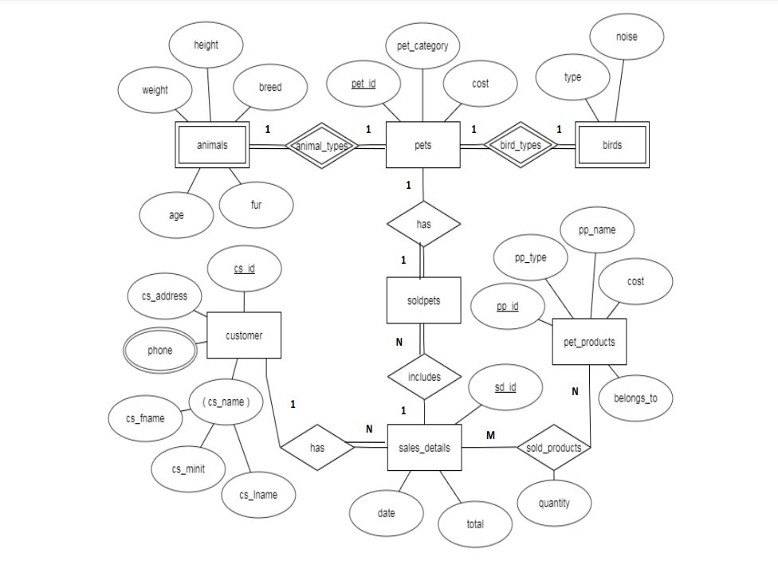

**SCHEMA DIAGRAM**

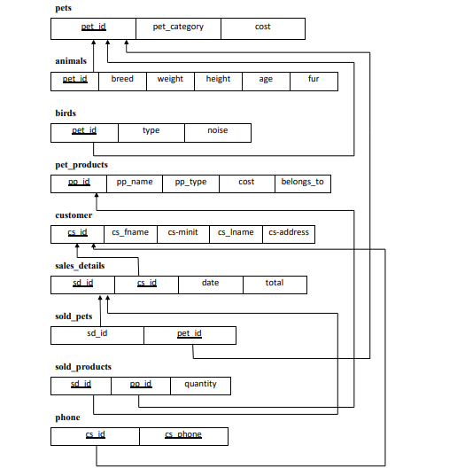

**CHAPTER 3:**

# IMPLEMENTATION

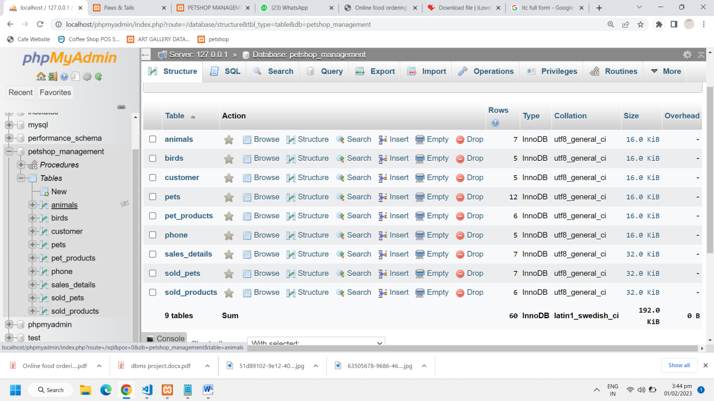

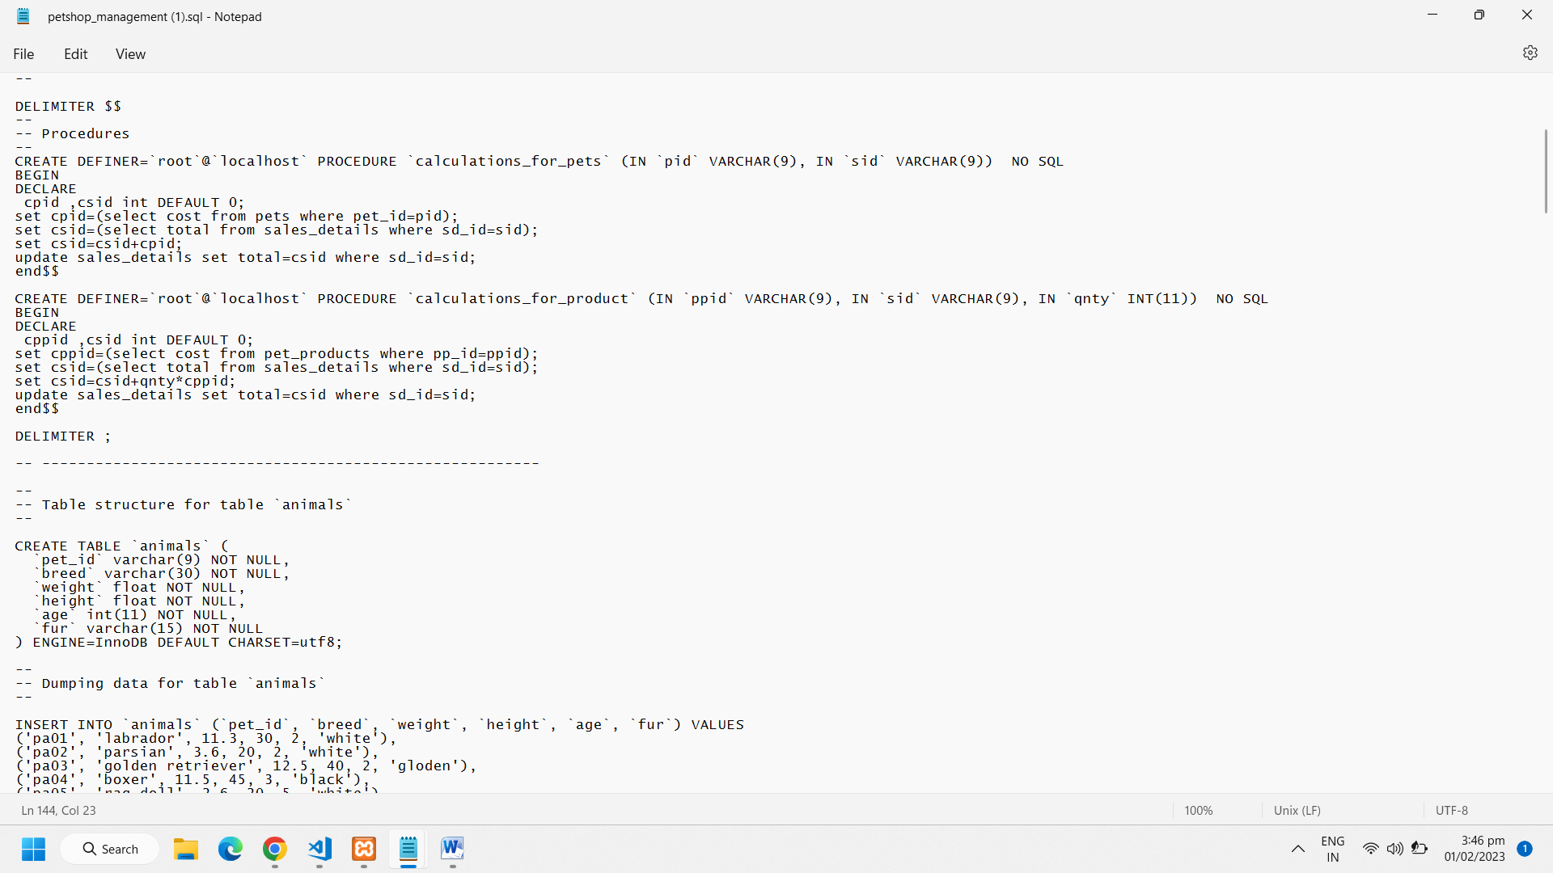

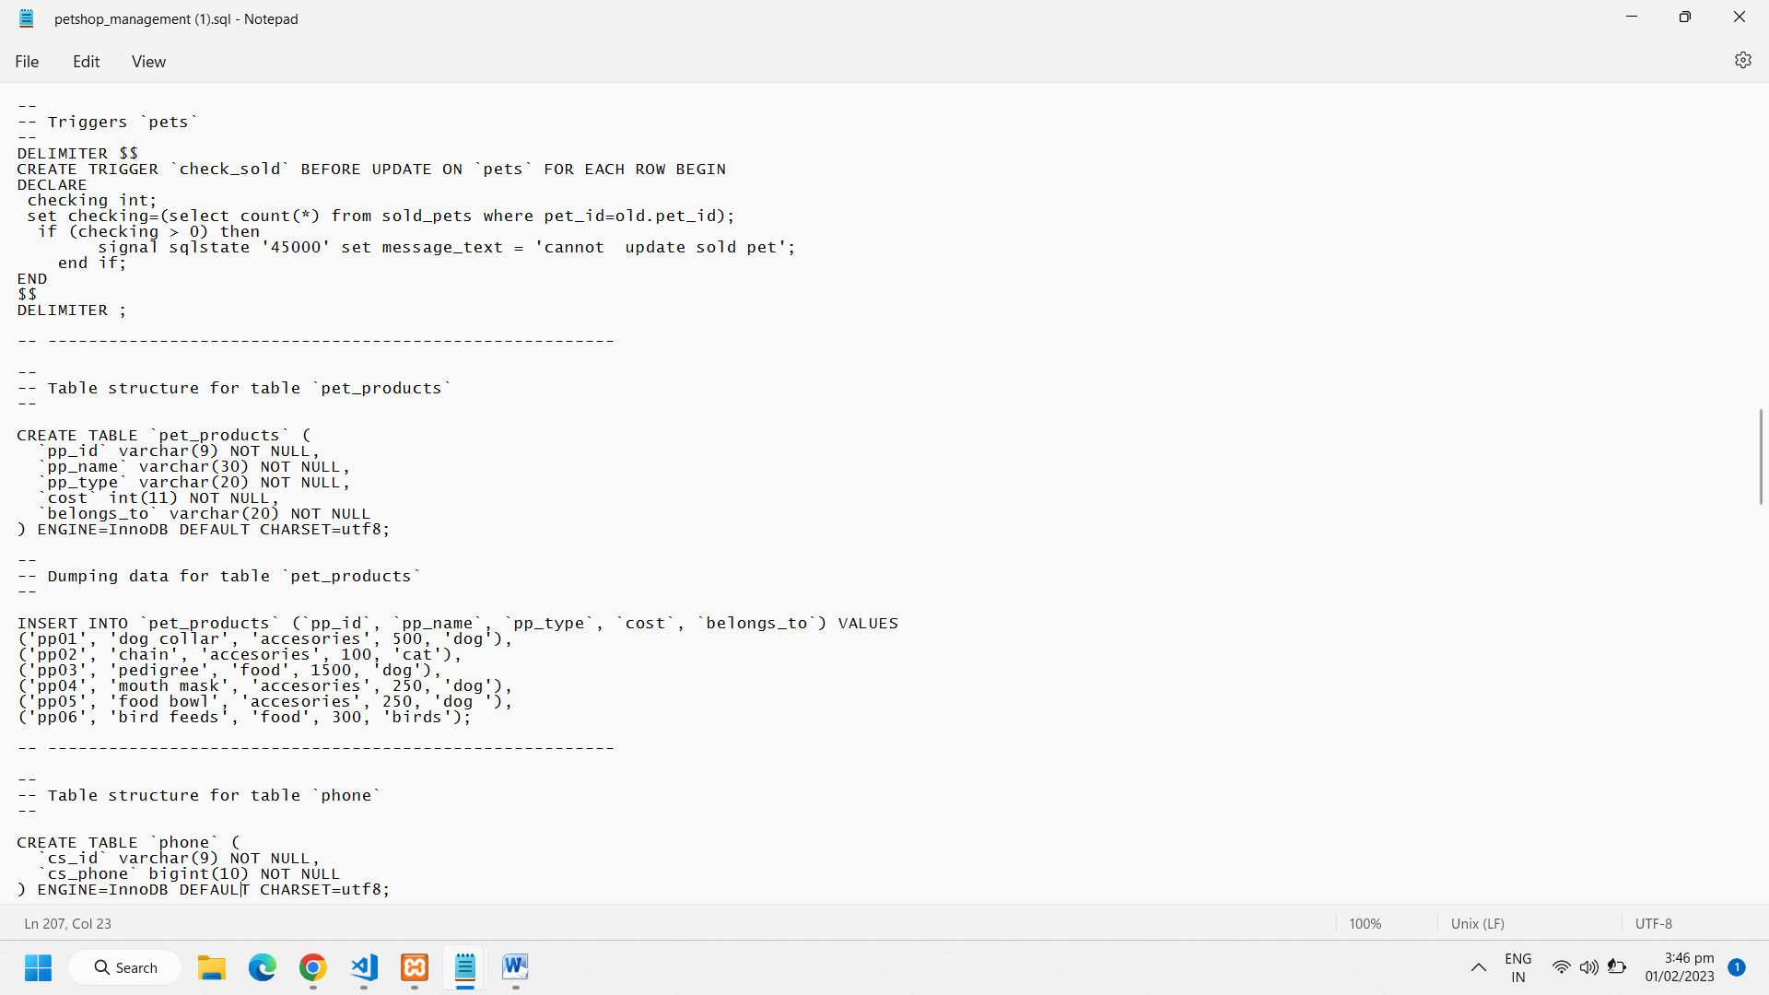

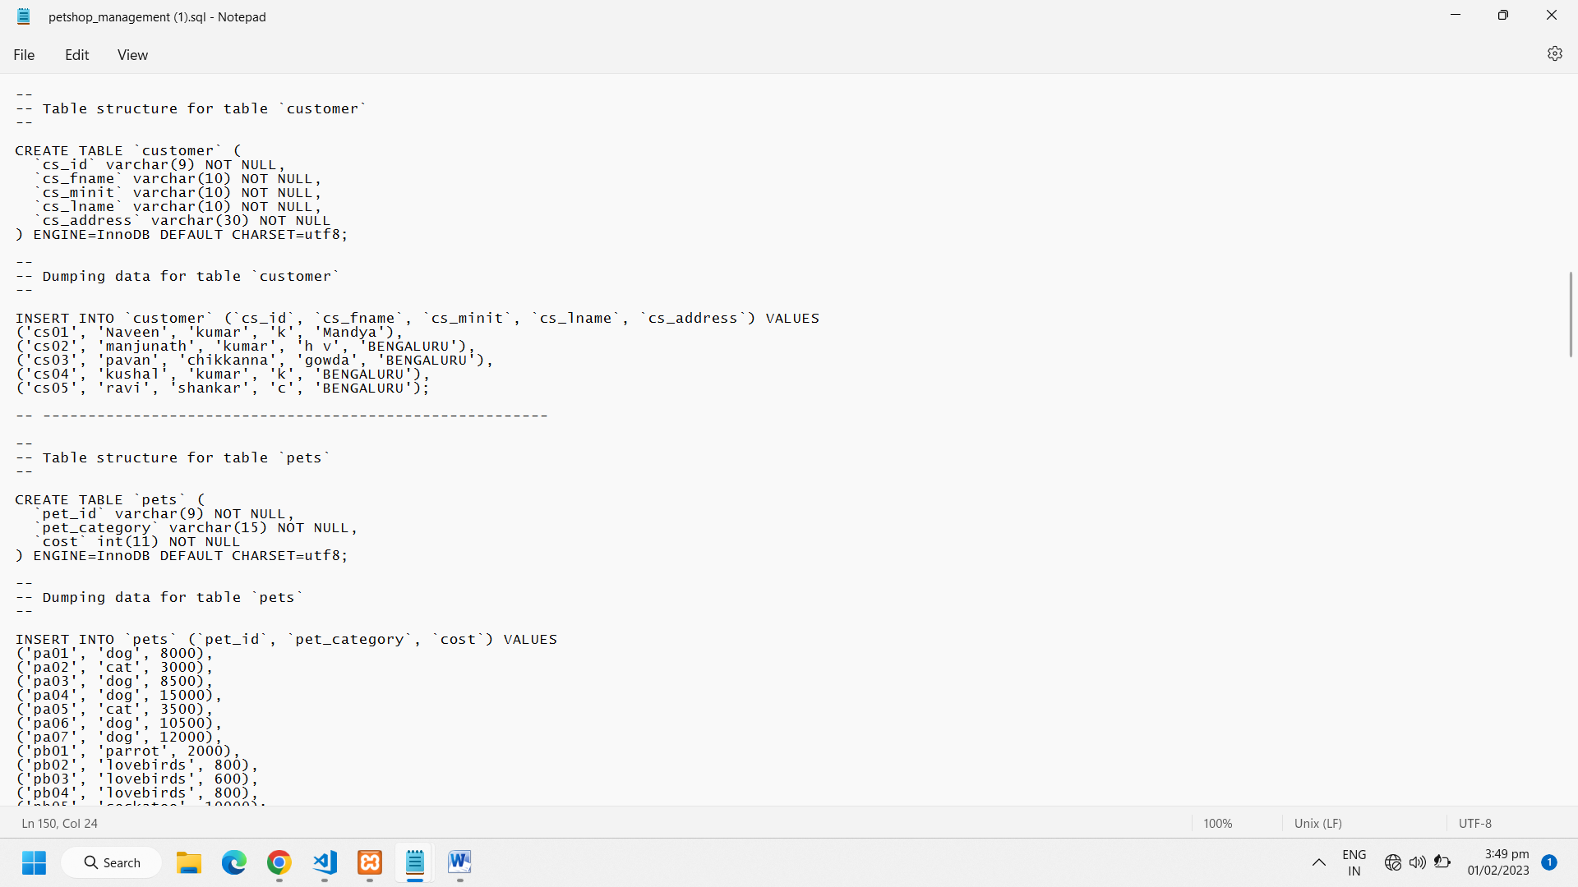

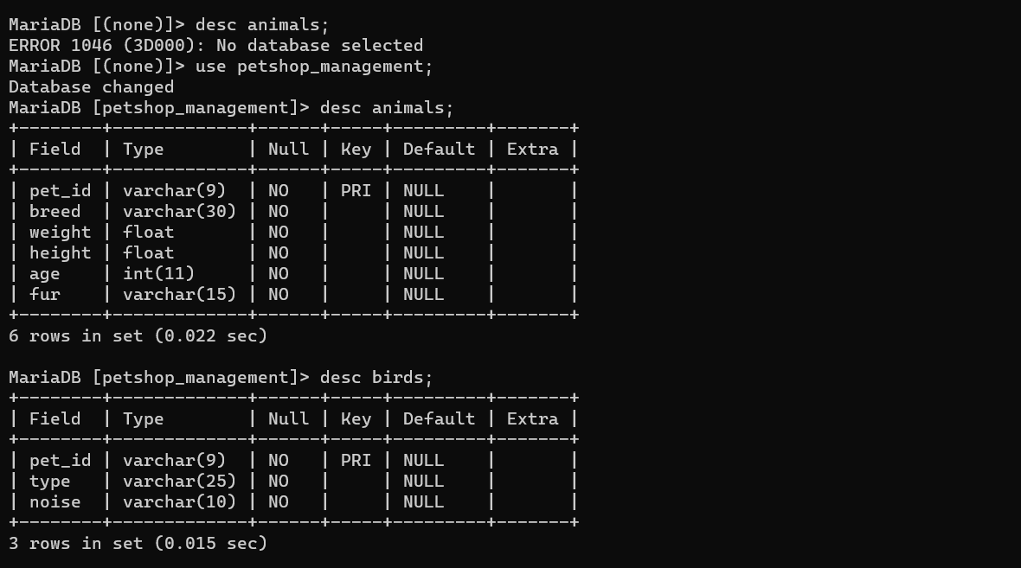

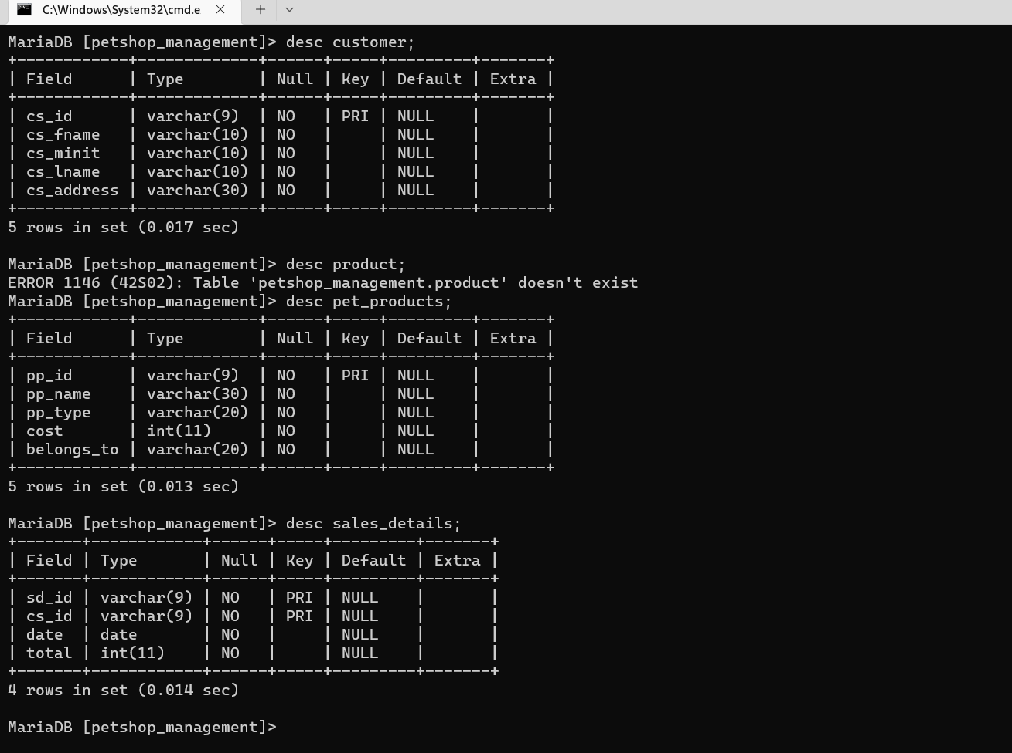

**GUI Implementation**

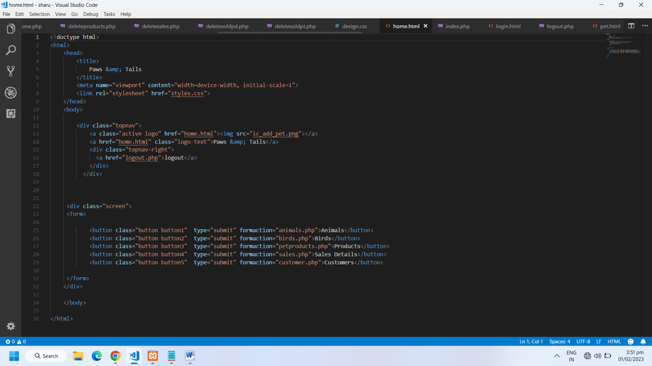

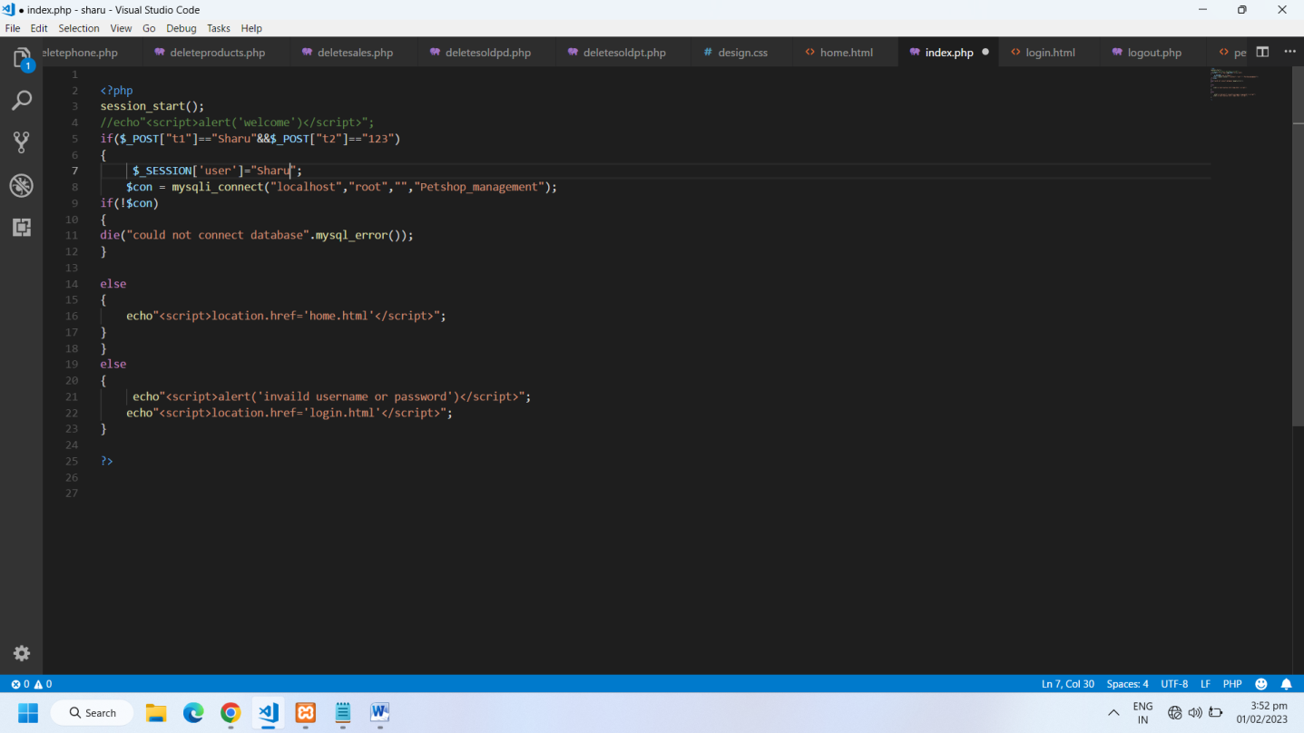

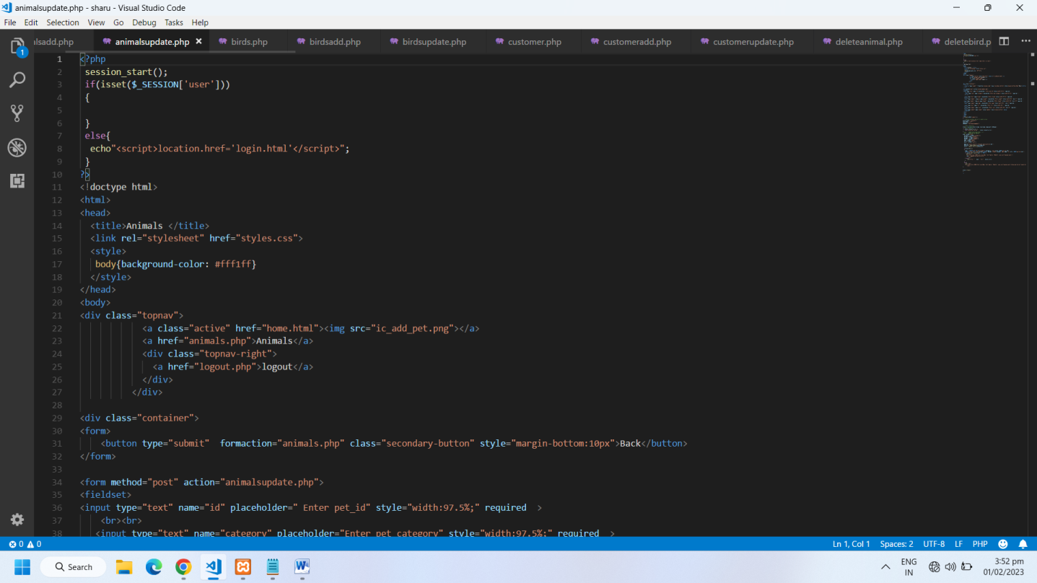

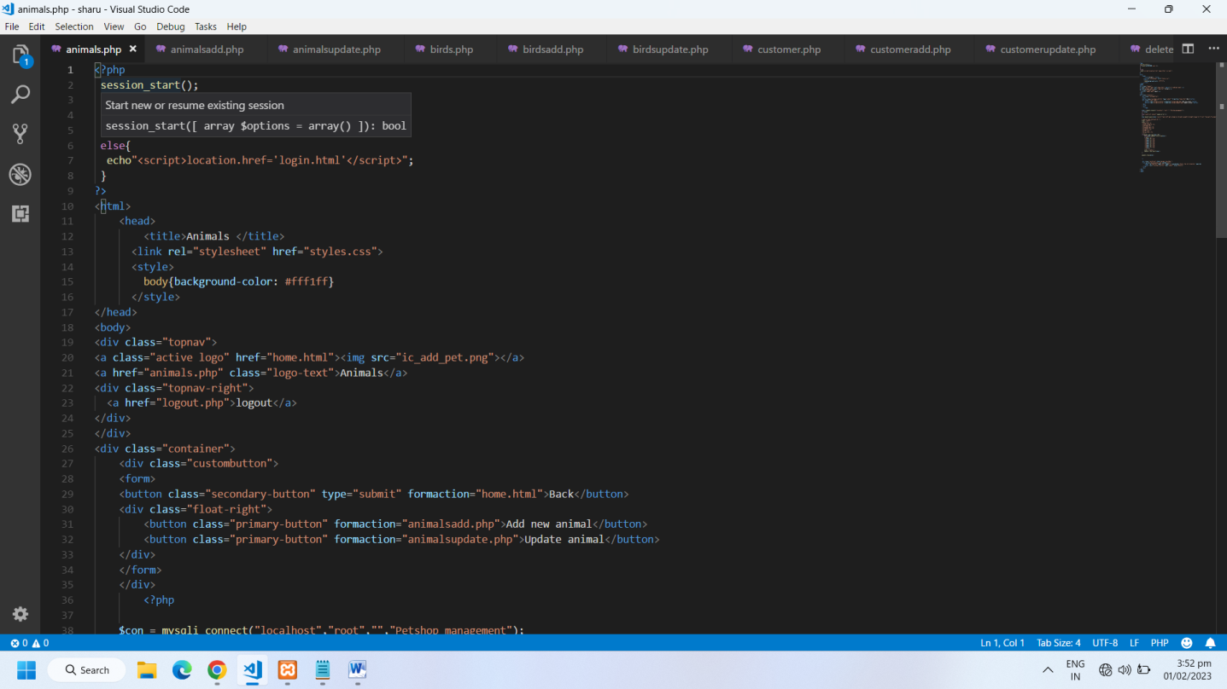

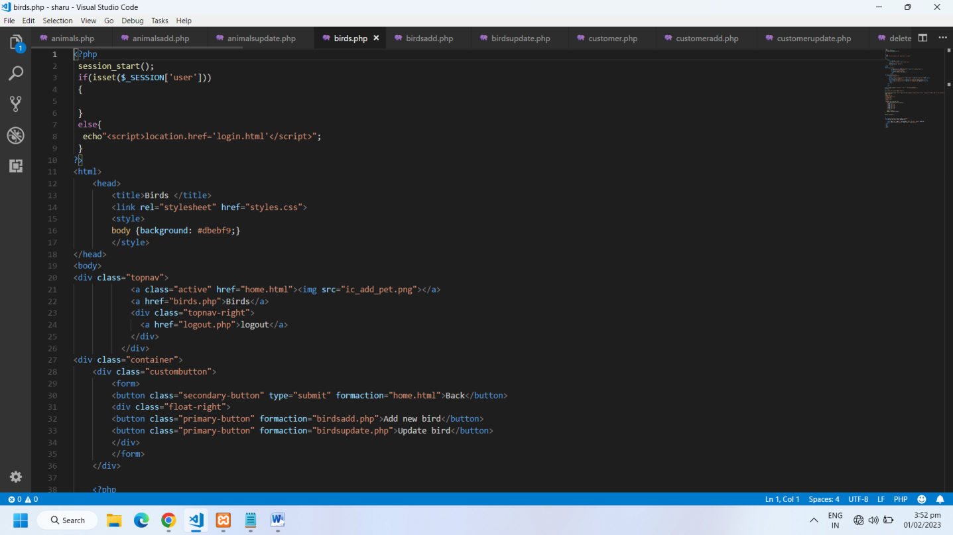

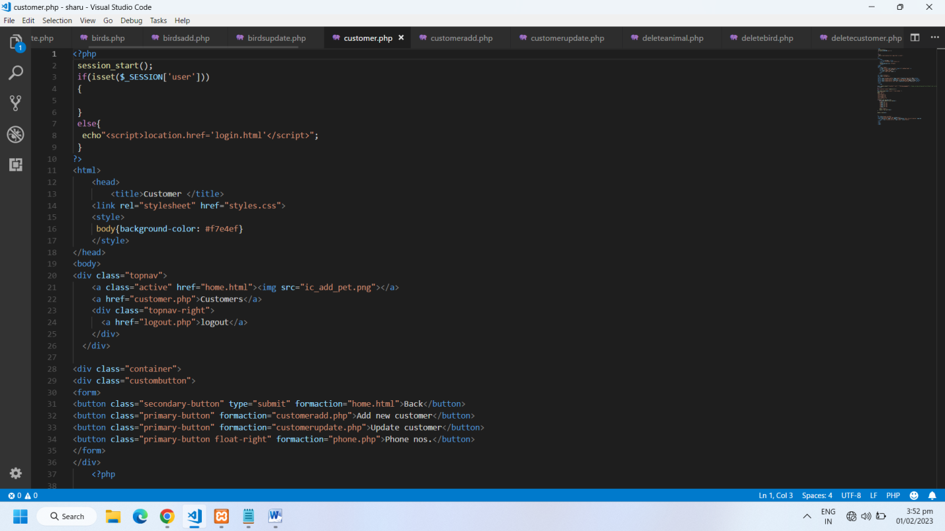

**CHAPTER 4:**

**RESULTS AND SNAPSHOTS**

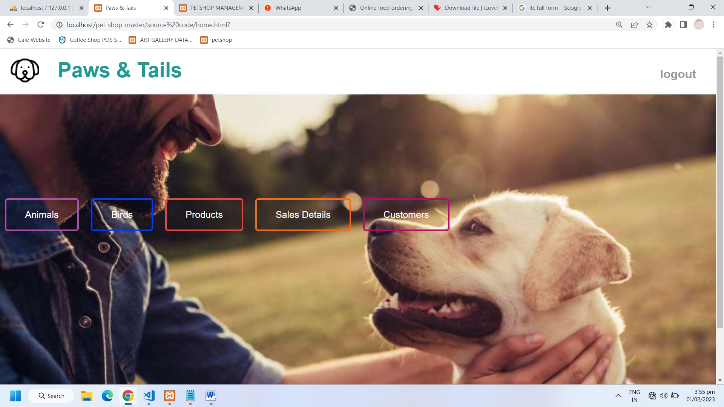

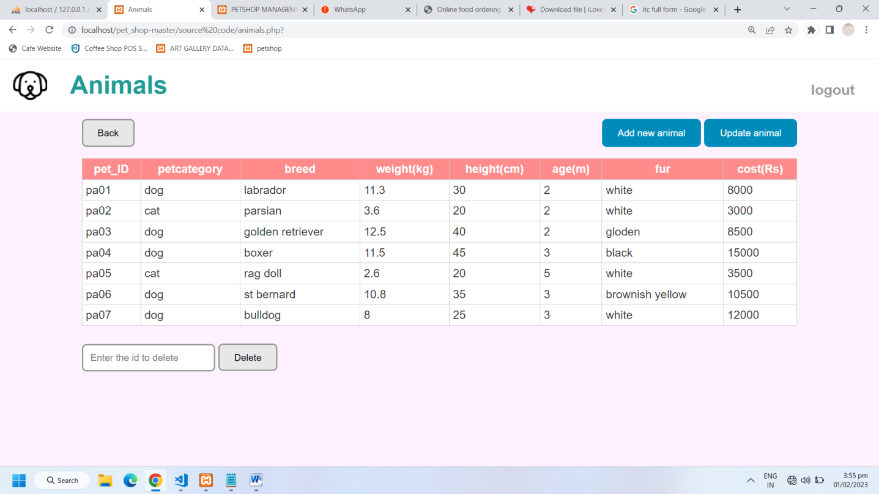

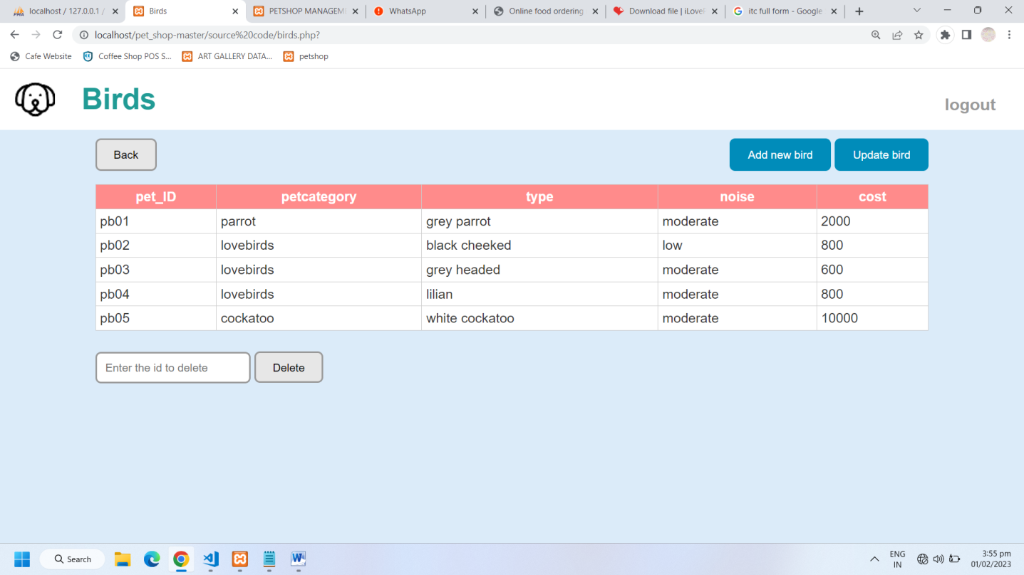

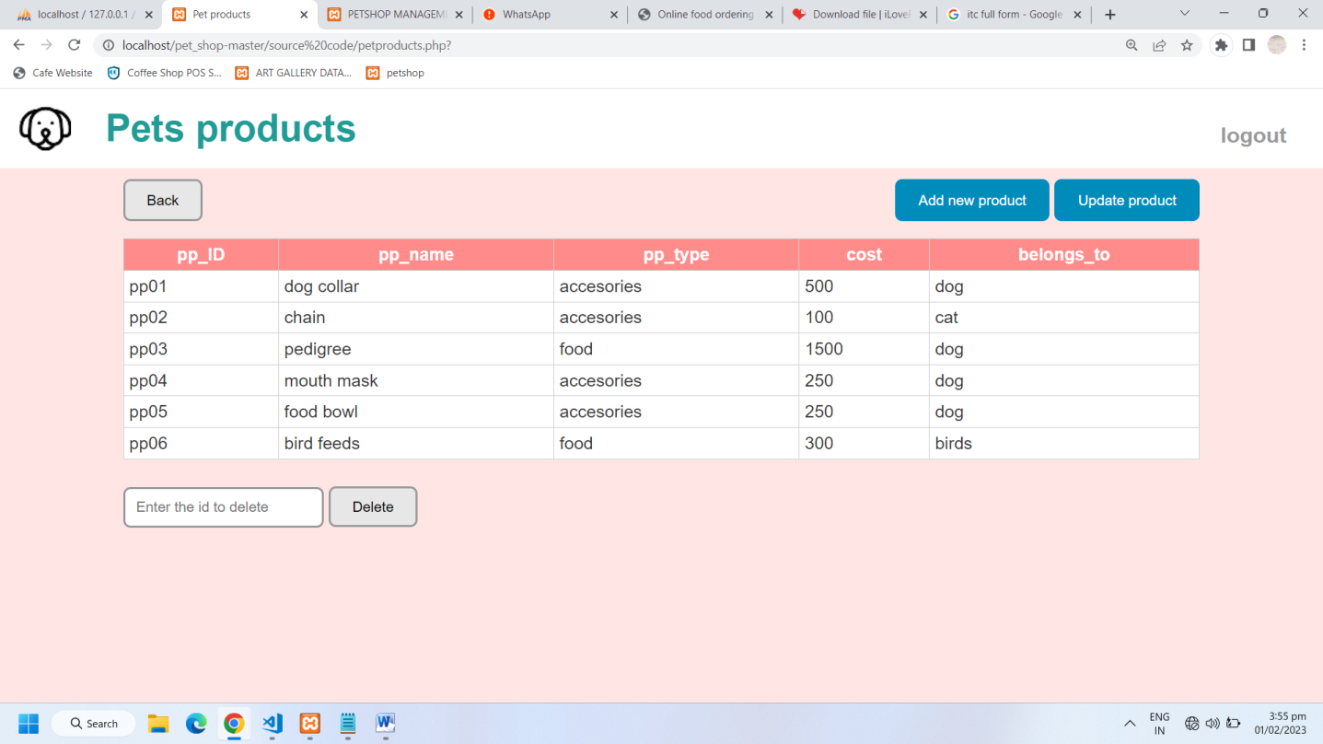

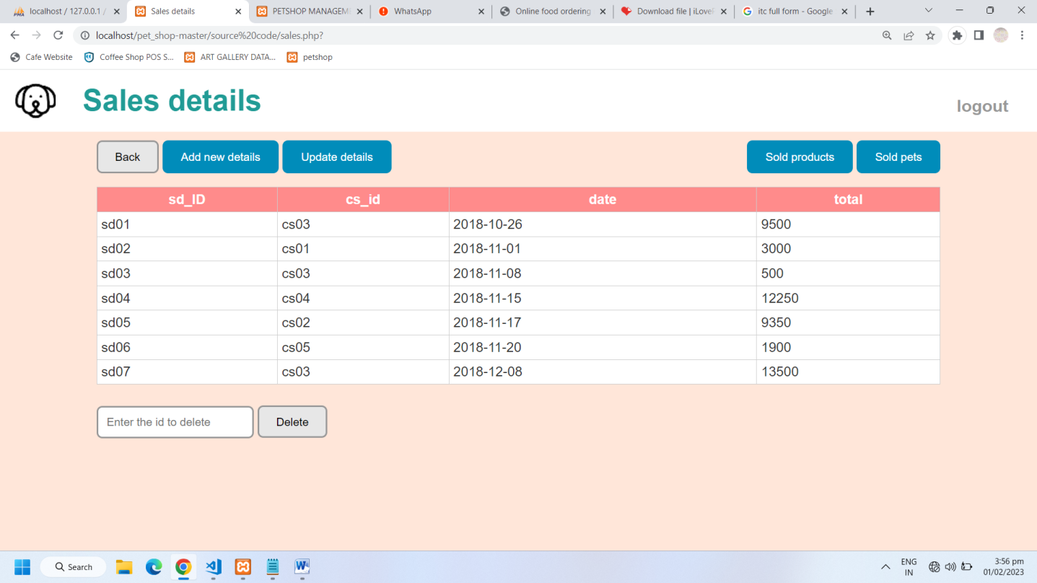

**User Login Page**

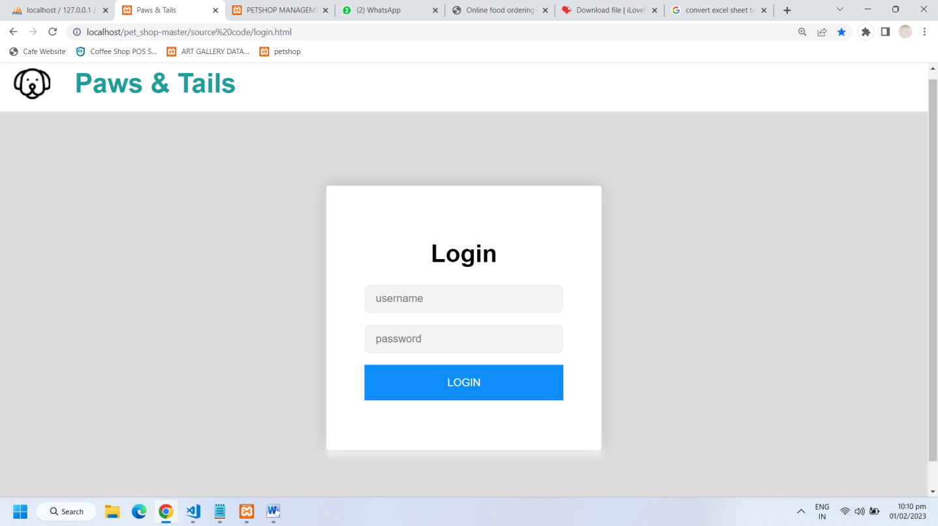

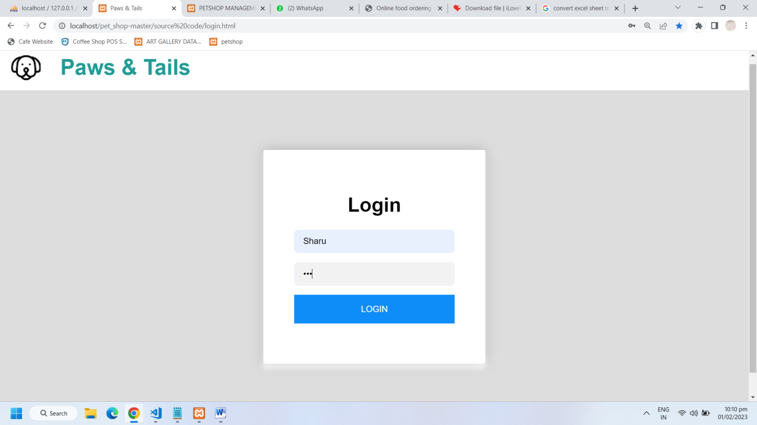

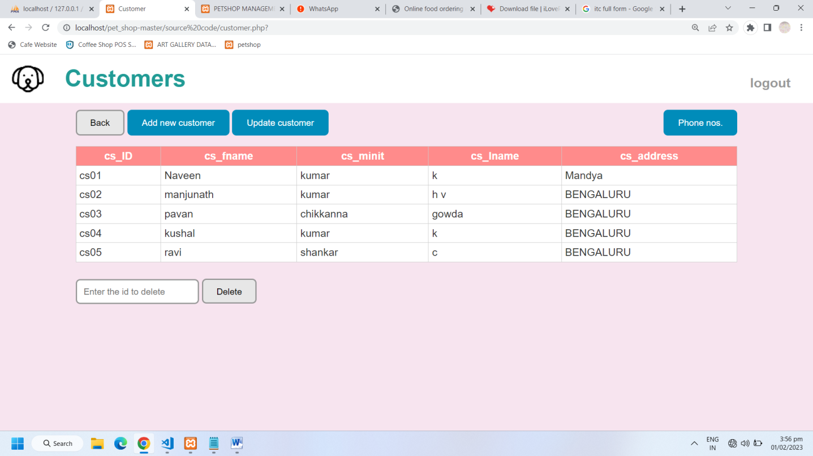

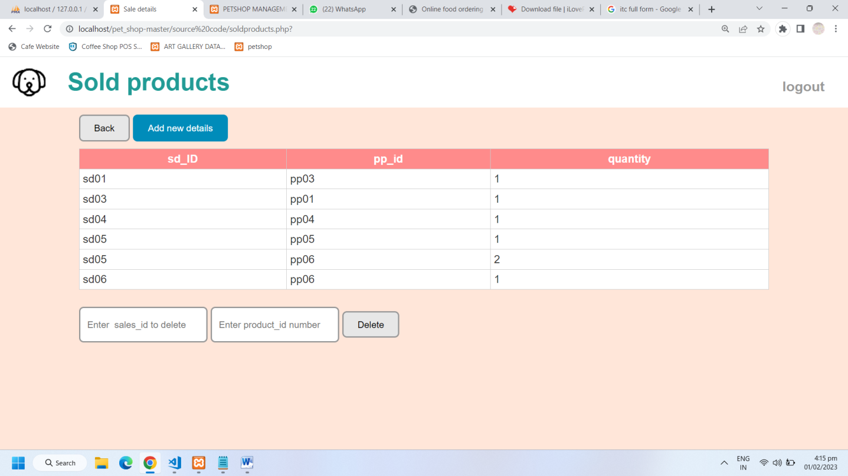

# Conclusion

The development of this Pet shop Management System is great improvement over the manual system which uses lots of manual work and paper. The computerization of the system speeds up the process. The Pet shop Management System is fast, efficient and reliable, Avoids data redundancy and inconsistency. It contains all the functional features described in objective of the project.

# Features

1. A password system that will be embedded into login page to increase the Security of the system.
2. Keeping a track of the animals in the shop.
3. A data required for different operations are accessible to the admin.
4. Quick and easy saving and loading of database file.

# HADWARE AND SOFTWARE REQUIREMENTS

## HARDWARE REQUIREMENTS

* 1. Windows 10 or Windows 11
  2. Intel Core i5 processor
  3. 16GB RAM
  4. Keyboard
  5. Monitor

## SOFTWARE REQUIREMENTS

1. PHP
2. XAMPP
3. MySQL